**OUTREACH SCHOOLS EXAMINATION BOARD**

**BEGINNING OF TERM III EXAMINATION 2023**

**TOP CLASS: (5 – 6 YEARS)**

**LEARNING AREA 1: SOCIAL DEVELOPMENT**

**My name is: ……………………………………………………………….**

**My School is: …………………………………….………………………..**

**I am in: ………………………………..…………………………….…………………..**

1. **Draw the weather conditions**

|  |  |
| --- | --- |
|  |  |
| rainy | sunny |
|  |  |
| cloudy | windy |

1. **[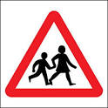](http://www.google.com/imgres?imgurl=http://www.proshieldsafetysigns.co.uk/signs/7557_signs.jpg&imgrefurl=http://www.proshieldsafetysigns.co.uk/signs/7557_Road_traffic_signs_Children_crossing.html&usg=__JgN4AERuoHUX0DF832mgDDTnvG8=&h=400&w=400&sz=41&hl=en&start=35&zoom=1&tbnid=ZqjTQLMJBAID4M:&tbnh=124&tbnw=124&ei=IkQ0UfTLDZOThgfIxoHwBg&prev=/search?q=pictures+of+children+crossing+the+road&start=20&um=1&hl=en&sa=N&gbv=2&tbm=isch&um=1&itbs=1&sa=X&ved=0CEYQrQMwDjgU)Name the road signs.**

______________

**Zebra crossing**

**Parking**

**School ahead**

**Traffic lights**

**No parking**

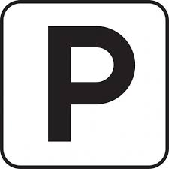

______________

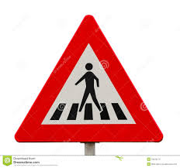

______________

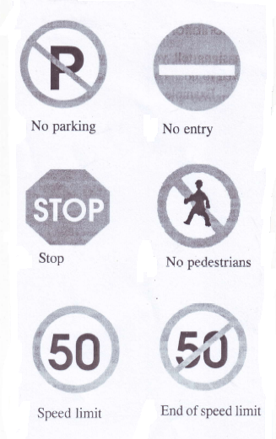

______________

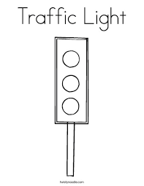

_____________

1. **Match the means of transport to the types.**

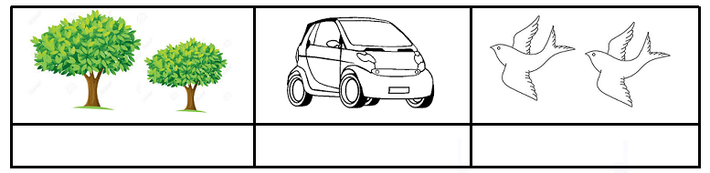

water transport

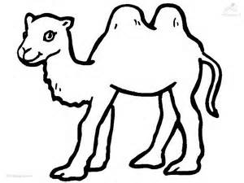

road transport

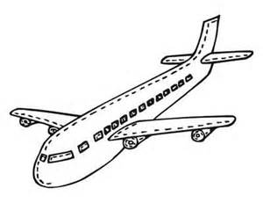

animal transport

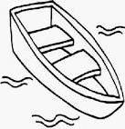

air transport

1. **Draw and shade a church.**
2. **Match people to their place of work.**

teacher hospital

priest garden

farmer mosque

policeman church

Imam policeman

doctor school

**End**